Table of Contents

Executive Summary 2
Introduction 3
Background of the industry 4
Data Quality Assessment 5
Redundant Data 5
Mismatched Data 7
Spelling Errors 7
Overall Performance Analytics 8
Financial Analytics 13
Operational Analytics 18
2 years Forecast Analytics 23
APPENDIX 28
Overall Performance Analytics 28
Financial Analytics 29
Operational Analytics 30
2 Years Forecast Analytics 31
Conclusion 32
References 33

Executive Summary

Between 2019 and 2023, SparkEV experienced varied market performance globally. In North America, sales peaked in 2019 but dropped sharply by 2023. In Asia, sales were highest in 2020, declining significantly by 2023. European sales started moderate and decreased further by 2023.
The Storm model significantly outsold the Gallen model. Cars made in the USA sold mainly in North America and select European areas, while Thai-made vehicles dominated Southeast Asia.
Financially, while car model revenues fluctuated, the USA stood out as the primary revenue source, backed by sales in Canada, Mexico, and Southeast Asia. The Romeno model sold the fastest, while the Stormz model lingered on lots. Gray was the favored color.
For future financial stability, SparkEV needs to revisit its product lineup, pricing, and resources. Despite success in some areas, the overall sales decrease by 2023 indicates a need for strategic adjustment in the rapidly changing EV market.

Introduction

In an increasingly digital age, data analytics has become paramount for industries seeking innovation and strategic insight, particularly in the competitive automobile sector. Among the contenders, SparkEV distinguishes itself as more than just another electric vehicle manufacturer. Instead, it merges automotive expertise with cutting-edge data science to create vehicles that resonate with contemporary consumers. Through data, SparkEV deciphers complex consumer behaviors, optimizes its operations, and anticipates market trends. Their approach transcends mere number-crunching, viewing data as the voice of their customers and a roadmap to innovation. By employing tools like predictive analytics and data visualization, SparkEV is not only poised to stay ahead of market shifts but also ensures coherent decision-making across its operations. As the electric vehicle domain evolves, SparkEV's data-driven strategy promises to redefine industry benchmarks, heralding a new era of sustainable and customer-centric mobility.
Background of the industry

The automotive sector is undergoing significant changes due to emerging market growth, technological advancements, sustainability efforts, and shifts in consumer attitudes towards car ownership, leading to an industry-wide overhaul (Gao et al., 2016). Digitization and automation, pivotal in other sectors, now influence the automotive industry, introducing key trends such as diverse mobility, autonomous vehicles, electrification, and improved connectivity.
SparkEV's Emergence and Expansion
SparkEV, a newcomer in this evolving sector, started three years ago, focusing on electric mobility. With a commitment to innovation and flexibility, SparkEV provides a range of customizable electric vehicles. The company, with factories in the USA and Thailand, has expanded to 13 countries in North America, Asia, and Europe, showing remarkable growth and gaining consumer trust worldwide.

Data Quality Assessment

Redundant Data

During the data cleaning process, we have found data with similar VIN# (Unique ID for the car). Since all the columns of the data are not similar. We have removed all the rows with similar VIN#.
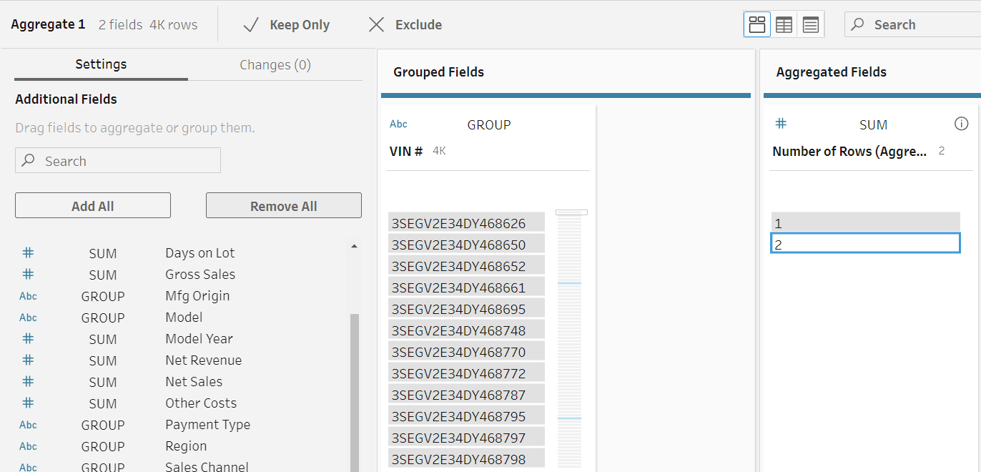
Figure 1:Redundant Data

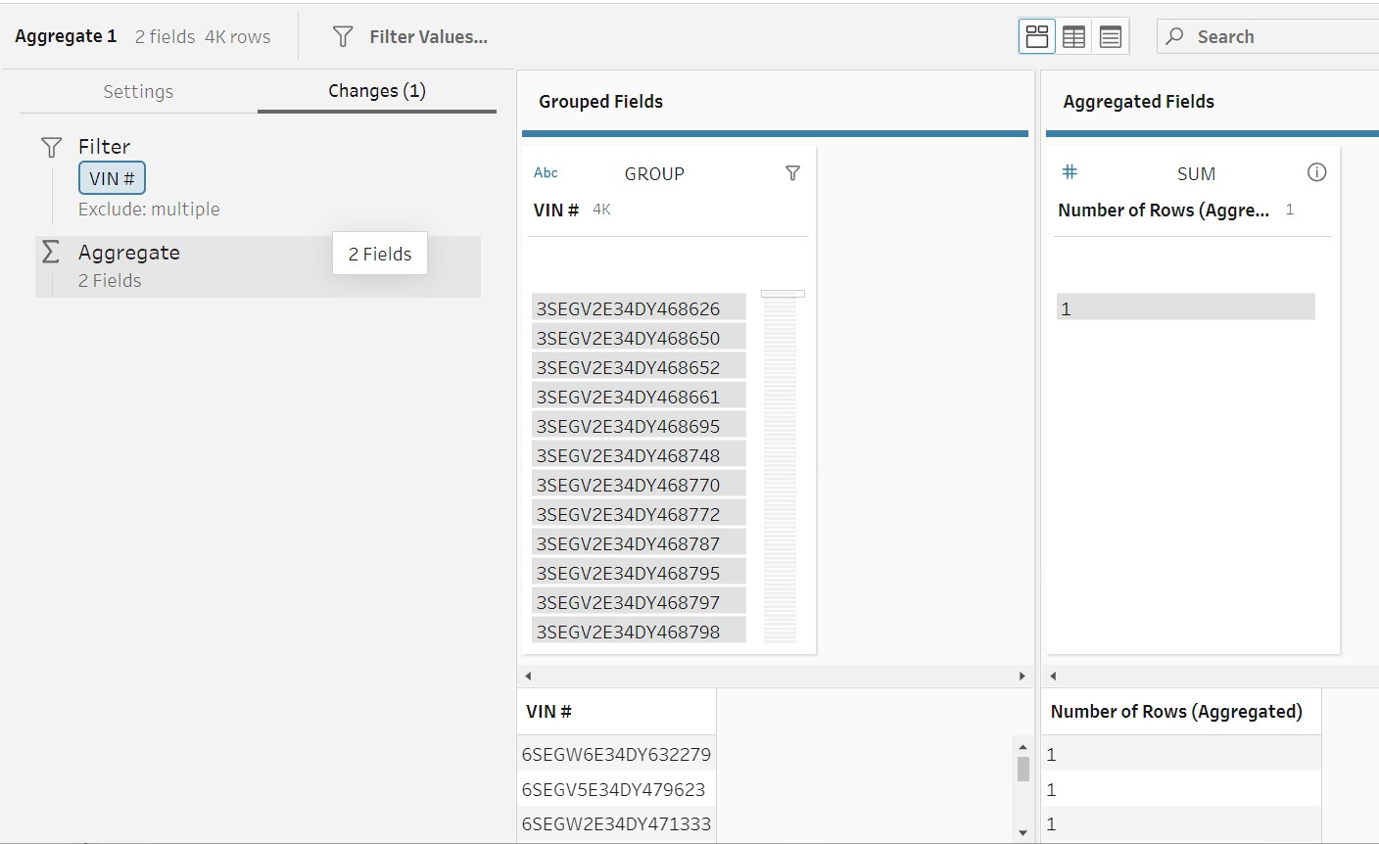
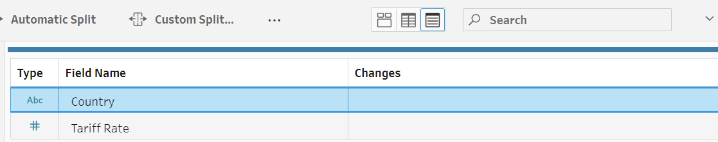
Figure 2: Similar VIN# (Unique ID)
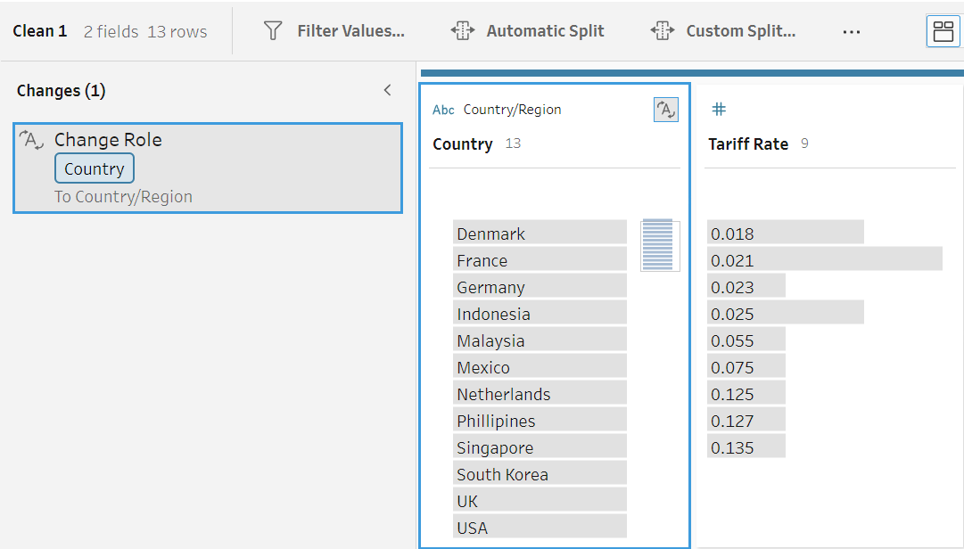
Figure 3: Country to Country/ Region to identify invalid value.
We have changed the Country data role to Country/Region to identify the invalid value.

Mismatched Data
- Identified mismatched data in 'Country of Sales' column of the primary table.
- Found two variations: 'United States' and 'USA'; merged these into 'USA'.
- Altered 'United Kingdom' to 'UK' for consistency with the Tariff Rate table.

Spelling Errors
In the Tariff rates table Philippines was misspelled which is has been corrected.
Figure 4: Spelling Difference in Primary Table vs Tariff Rate Table

Overall Performance Analytics

As we navigate through the evolving landscape of the automobile industry, the sales performance of brands across key markets offers insights into their market positioning, brand acceptance, and competitive standing. In this context, we analyze the sales trajectory of SparkEV across three major markets: North America, Asia, and Europe, spanning from 2019 to 2023.

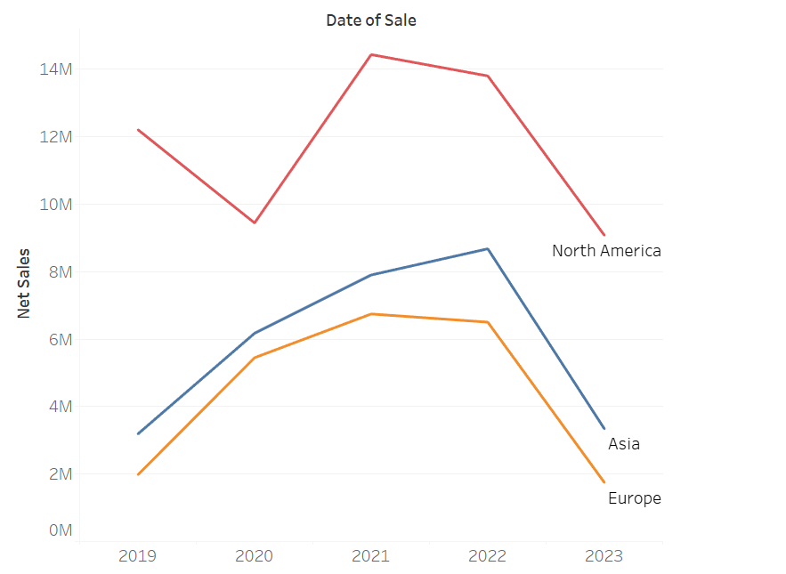
- What trends in market share have been observed for SparkEV in North America, Asia, and Europe?
Figure 5: Date of sale vs Net sales Line chart
Analysis:
North America:
2019: Strong start, leading in sales among all regions.
2020: Sales declined, indicating potential market challenges or competition.
2021: Partial recovery, yet not matching the 2019 peak.
2022-2023: Continuous decline, with 2023 hitting the lowest point.

Asia:
2019: Moderate sales, indicating potential for growth.
2020: Marked increase in sales.
2021: Slight improvement but remains modest compared to other regions.
2022-2023: Improved in 2022 but continued decline, with minimal sales in 2023.
Europe:
2019: Decent sales, though behind North America and Asia.
2020: Increase in sales, mirroring trends in other regions.
2021: Brief recovery.
2022-2023: Steady decline, reaching a low in 2023.

From 2019 to 2023, SparkEV's market trends fluctuated across regions. North America saw a strong start but faced a steep decline to the lowest sales in 2023. Asia initially showed promise with increasing sales till 2020, then experienced a decline. Europe's sales followed a similar rise and fall, also reaching a low in 2023. These trends reflect changing market dynamics and regional consumer behaviors.

- Which car models have demonstrated exceptional sales performance, and which ones require improvement?
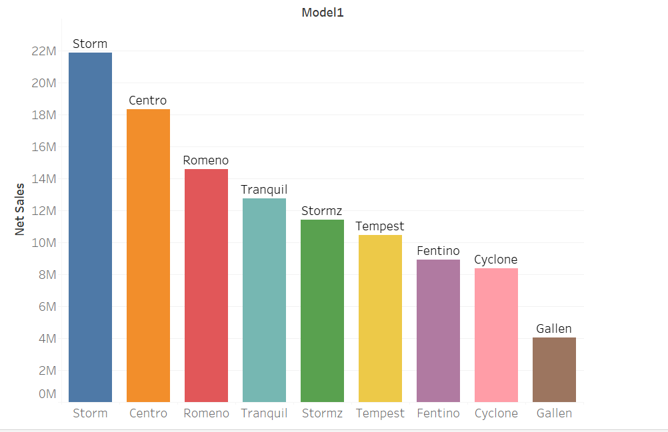
Figure 6: Sale performance by models
Bar Chart: Total Sales Per Model (2019-2023)
The bar chart brilliantly encapsulates the financial narrative of SparkEV's diverse car models revealing insights into their respective market penetrations. Each bar, representing a unique model, stretches towards its cumulative sales figure, narrating a story of its journey in the marketplace. The towering presence of the Storm model, with the loftiest bar, signifies its stellar sales performance and unequivocal acceptance in the market. In stark contrast, the Gallen model, with its modest stature, reflects a more subdued market presence, potentially signaling underlying challenges in competitive positioning or consumer appeal. This visualization elegantly stratifies the models, providing a clear, instantaneous snapshot of their financial footprints in the market.

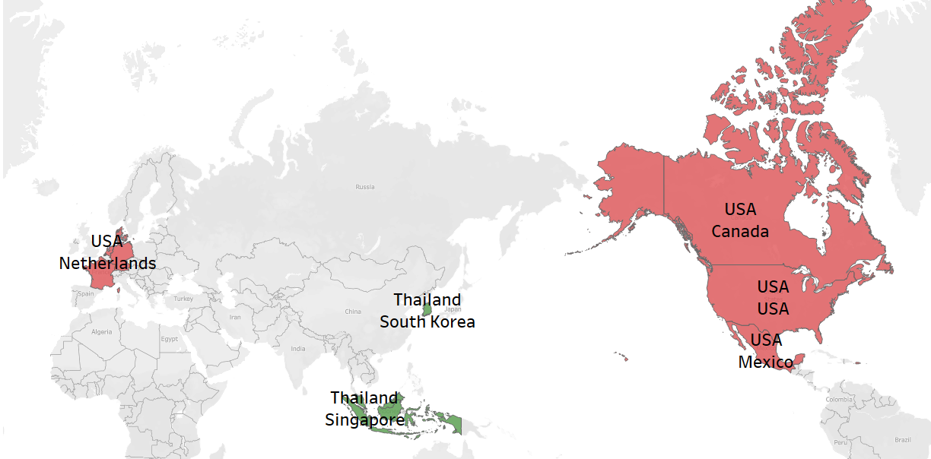
- Considering the manufacturing origins (USA and Thailand), is there a noticeable difference in sales performance or customer preference for cars produced in one location over the other?
Figure 7: difference in sales performance or customer preference for cars produced in one location over the other

The Tableau map visualization, pinpointed by latitude and longitude, distinctly showcases SparkEV's sales influenced by manufacturing origins. red markers, representing cars made in the USA, are predominant in North America and parts of Europe, hinting at a marked preference or strategic distribution in these areas. On the other hand, green markers, symbolizing cars manufactured in Thailand, are prominent in regions like Southeast Asia, indicating a strong local preference or the advantage of proximity. The variability in marker sizes across regions further emphasizes the sales volume, with more substantial markers signifying higher sales. In essence, this map provides a clear depiction of regional sales preferences tied to each manufacturing hub.
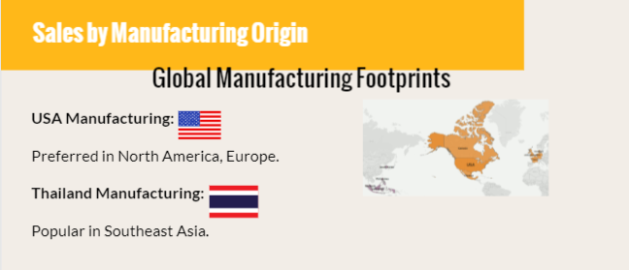
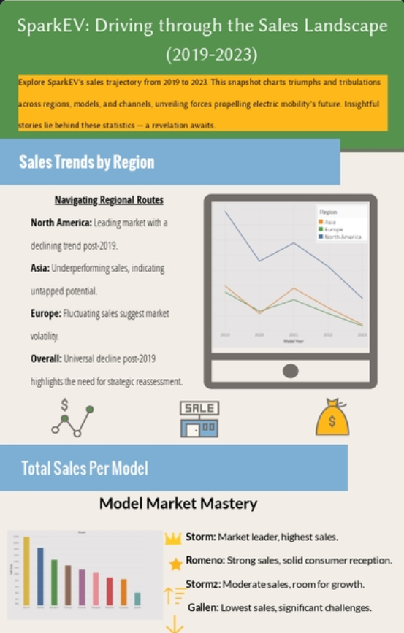
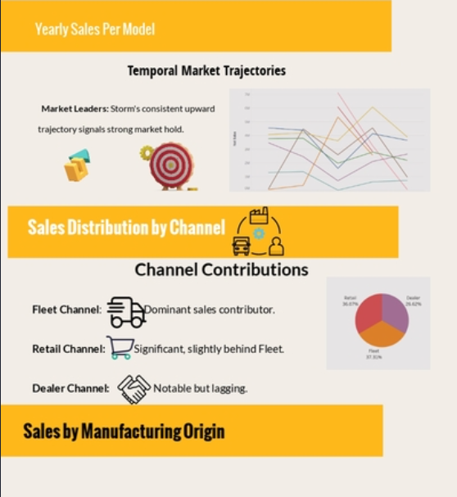
Infographics
Figure 8: Infographic 1(Overall Performance Analytics)

Financial Analytics

Our financial analysis of SparkEV focuses on key metrics like total variable costs, operational expenses, net revenue, and after-tax profits. This thorough review seeks to identify profitability and cost efficiency, aiding in resource allocation and strategic planning. Understanding these financial aspects will help SparkEV achieve sustainable growth and competitiveness in the electric vehicle industry.

- Average Net Revenue Per Model in Different Year
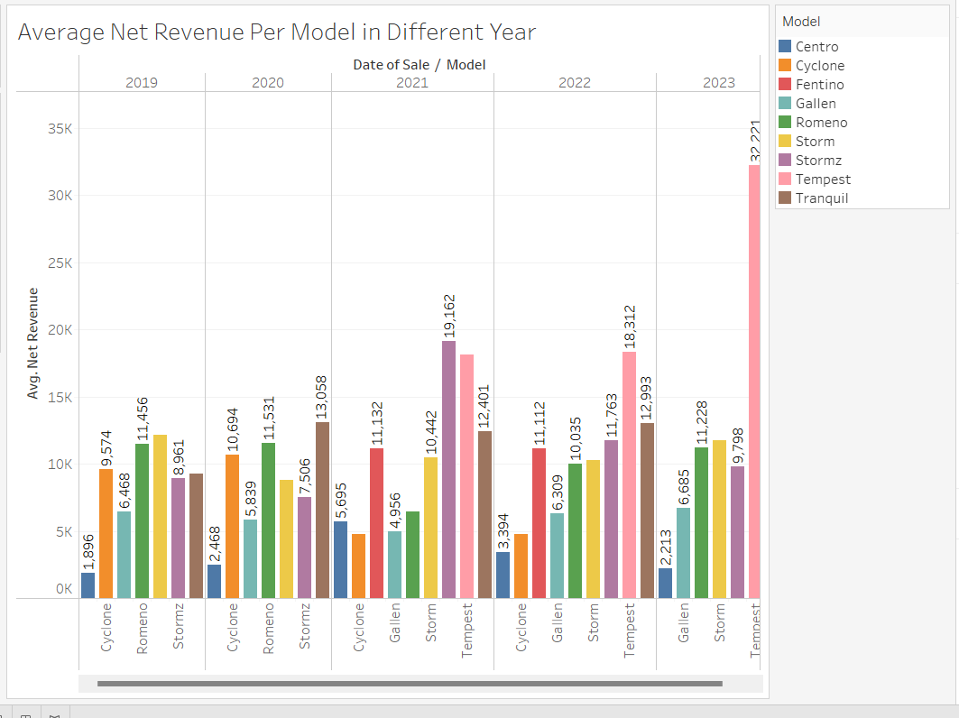
Figure 9: Average net revenue per model in different year
The provided bar chart titled "Average Net Revenue Per Model in Different Year" showcases the financial performance of various models from 2019 to 2023. The models in focus are Centro, Cyclone, Fentino, Gallen, Romeno, Storm, Stormz, Tempest, and Tranquil. A striking observation is the upward trajectory in average net revenue for most models, particularly evident between 2022 and 2023. In 2023, the "Tranquil" model emerges as the top performer with a revenue just above 30K. Meanwhile, the "Storm" model impressively registers consistent growth throughout the years, peaking notably in 2023. Contrarily, the "Cyclone" model's revenue, which peaked in 2020, appears to be on a decline in subsequent years. Similarly, the "Romeno" model's revenue seems relatively stagnant, hinting at possible market challenges or product stagnation. On a brighter note, even though the "Tempest" model faced a dip in 2022, it rebounded commendably in 2023. Drawing from these insights, while most of the models reflect promising growth, especially in 2023, models like "Cyclone" might need strategic interventions to reverse the declining trend. The consistent growth of the "Storm" model and the standout performance of the "Tranquil" model in 2023 suggest that these models might be worthy of additional investment and marketing efforts.

Consistent Performance of the Storm Model: The "Storm" model demonstrates steadfast growth, suggesting substantial market approval and enduring demand. Stable performance of this sort is frequently witnessed in products that enjoy robust branding and customer loyalty (Keller, 2001).

- Net sales On the Basis of Model per Year
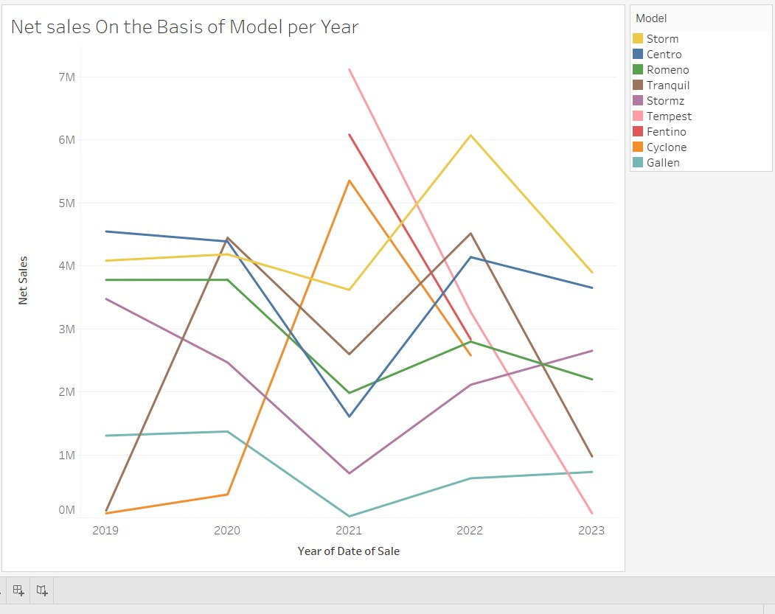
Figure 10: Net Sales on the basis of Model per year

The line graph presents "Net sales On the Basis of Model per Year" for the period spanning 2019 to 2023. The data focuses on models including Storm, Centro, Romeno, Tranquil, Stormz, Tempest, Fentino, Cyclone, and Gallen. Here's a paragraph-style analysis:

The graph portrays the net sales trends of various models from 2019 through 2023. Most prominent is the model "Fentino," which after maintaining steady sales close to the 5M mark in 2019 and 2020, experienced a remarkable spike in 2021, reaching just below 7M. However, this rise was short-lived, as Fentino's sales dramatically plummeted in the subsequent years, nearing 1M in 2023. The "Storm" model also had a tumultuous journey, starting at about 3M in 2019, escalating to nearly 6M in 2021, and then descending rapidly in the following years. The models "Cyclone" and "Gallen" display contrasting trajectories. While "Cyclone" had a robust start near 5M in 2019 but dwindled over time, "Gallen" commenced with modest sales in 2019 but saw an impressive climb in 2021. Nonetheless, both models faced sharp declines post-2021. Models "Centro," "Romeno," "Tranquil," "Stormz," and "Tempest" demonstrate relatively steadier trends, with minor fluctuations across the years. In 2023, most models converge at the lower spectrum of sales, indicating a challenging year for the majority.

In summation, while certain models experienced significant highs, especially in 2021, the overarching theme is the decline in sales for most models by 2023. Strategic interventions may be needed to reverse these trends and revitalize sales.

Consistent Performance of Centro Model: The "Centro" model exhibits a relatively stable sales volume throughout the years, hinting at consistent demand, likely due to brand loyalty or the model meeting specific market needs efficiently (Oliver, 1999)

- Net Revenue on Geographic map
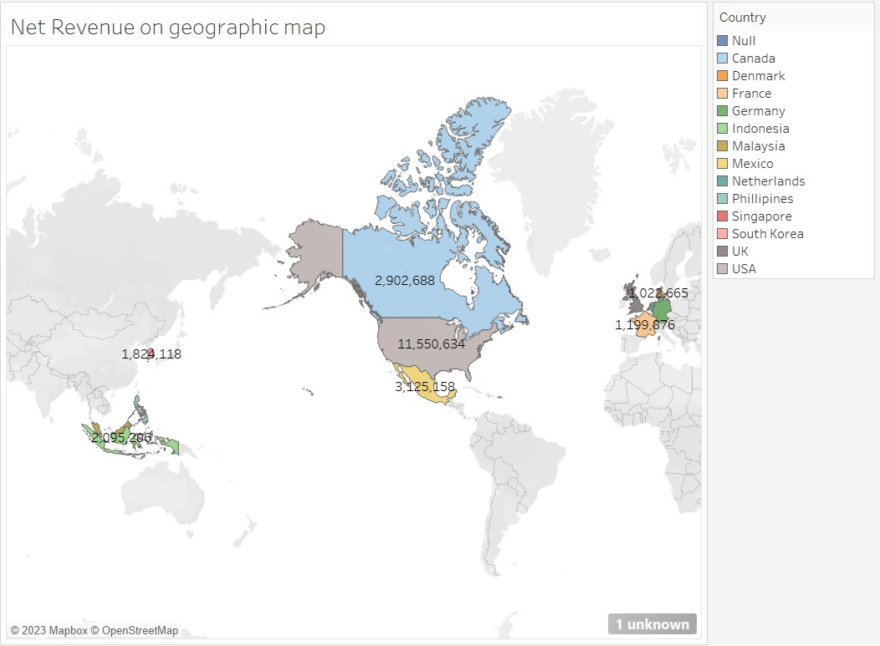
Figure 11: Net Revenue on Geographic map

The map provides a geographical representation of net revenue for various countries.

The USA stands out as the country with the highest net revenue, reaching an impressive 11,550,634. Canada follows with a substantial revenue of 2,902,688, while Mexico comes in slightly higher at 3,125,158. Notably, despite Mexico's revenue being lower than Canada's, it remains a significant contributor.

In Asia, the net revenue figures show diversity among countries. South Korea reports a net revenue of 1,199,876. In contrast, Indonesia, and Malaysia record revenues of 1,028,665 and 2,095,206, respectively, highlighting a robust market in Southeast Asia.

Europe's data, particularly for the UK, is not fully detailed in the current overview. Additionally, other regions of the world report revenues, such as 1,824,118, but without complete context, it's difficult to attribute this figure to a specific country or area. The presence of an 'unknown' marker on the map also suggests that some revenue data is associated with an unidentified or improperly labeled country or region.

In summary, while the USA dominates in net revenue, other countries like Canada, Mexico, and those in Southeast Asia also make notable contributions. For a complete understanding, however, it's crucial to include data from significant regions like Europe, Africa, and other parts of Asia.

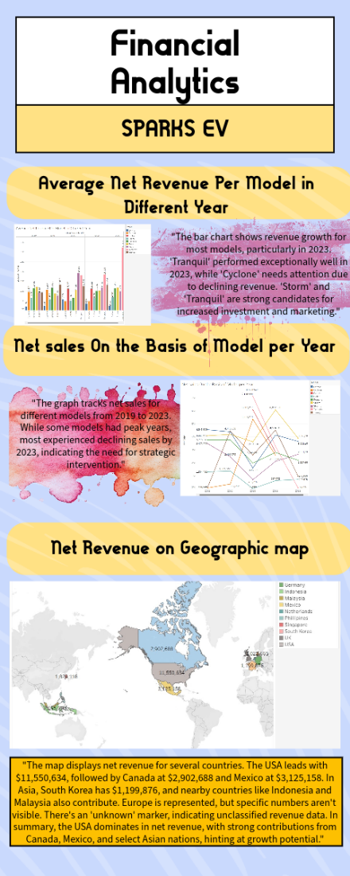
Figure 12: Infographic 2(Financial Analytics)

Operational Analytics

In today's business world, all companies encounter a stream of events, but the exceptional ones stand out by effectively gathering and using this data. Businesses using operational analytics aim to boost revenue and profitability through efficient real-time operations, extending beyond just one project in a small department. The four queries we've received are as follows:
- How many days are the various models on the lot prior to sale?
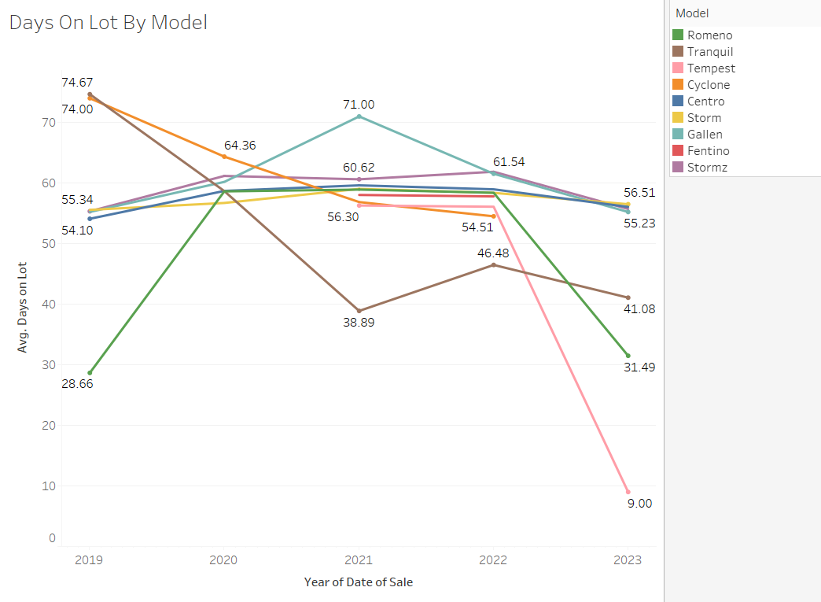
Figure 13: Days on lot by model

The chart "Days On Lot By Model" displays the average duration various car models stay on a lot before being sold. The Romeno model sells the fastest, averaging around 46 days, while the Stormz model tends to stay the longest at approximately 58.23 days. The difference between the fastest and slowest-selling models is about 9 days. Such insights are vital for businesses to strategize inventory management, sales promotions, and potentially reconsidering the continuation of specific models.
2. What model options are top and bottom sellers?

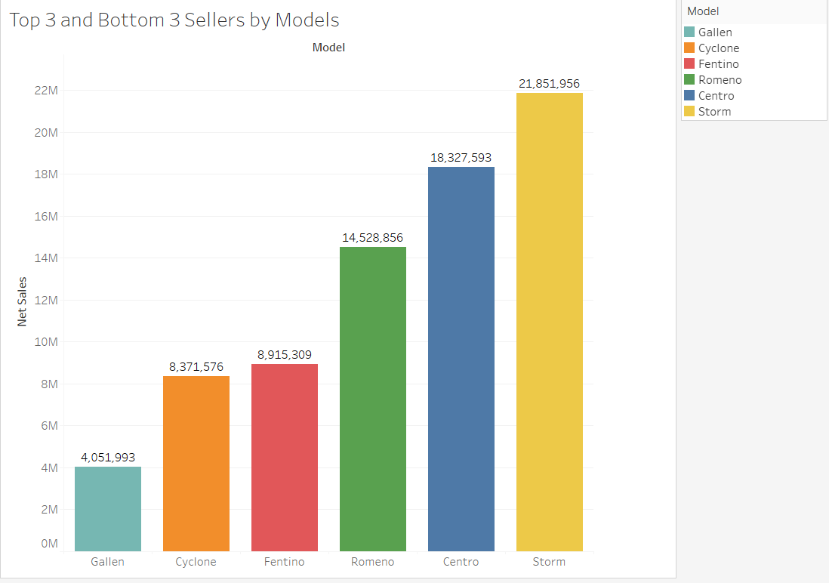
Figure 14: Top 3 and Bottom 3 sellers by model
The chart "Top 3 and Bottom 3 Sellers by Models" presents the net sales of different car models. The Storm model achieves the highest sales at approximately 21.85M, closely followed by Centro with around 18.33M, and Romeno at about 14.53M. On the contrary, Gallen, Cyclone, and Fentino models exhibit lower sales, with the Cyclone at 8.37M being the least performer. This data suggests that while models like Storm and Centro are market favorites, there might be a need to reassess the market positioning or features of the lower-performing models to boost their sales.

Dominance of Storm, Centro, and Romeno Models: The models "Storm," "Centro," and "Romeno" significantly outperform the others. Their high sales volume might be attributed to various factors such as superior product features, effective marketing campaigns, or widespread market acceptance (Porter, 1980).

3. How Seats/ Trim/ Colour affects Net sales

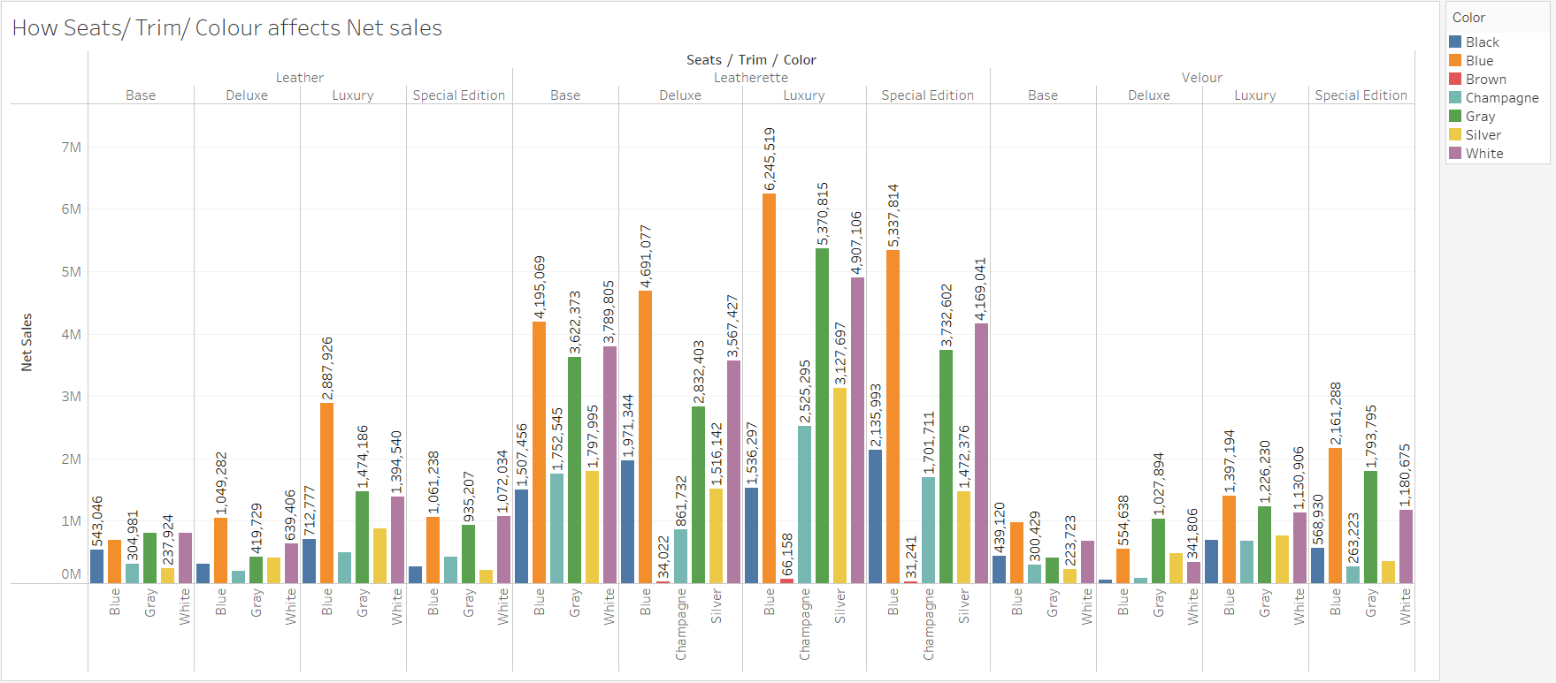
Figure 15: Factors affecting Net Sales
Special Edition Appeal: For almost every color, the "Special Edition" trim shows impressive sales figures, possibly implying that consumers are willing to invest in exclusive or limited features (Lynn, 1991).

Seats/Trim:
Leather:
Base leather seats with the color Gray appear to have the highest net sales.
Deluxe leather seats in the Gray and White colors also exhibit notable sales.

Leatherette:
The sales for Base and Deluxe variants seem evenly spread across multiple colors, with Gray, Blue, and Champagne being dominant.
Luxury and Special Edition Leatherette seats in the color Gray seem to stand out in terms of sales.

Velour:
Velour Base seats with the Blue color and Velour Deluxe seats with the Gray color have notable sales.

Color:
Gray is a dominant color across all seat types and trims, consistently showing high sales.
Blue and Champagne are also popular colors, especially for Leatherette seats.

Observations:
- Gray seems to be the most preferred color regardless of the type of seat/trim.
- Leather seats, especially in the Base and Deluxe trims, have strong sales, particularly in the Gray and White colors.
- Leatherette seats in the Luxury and Special Edition trims, especially in the Gray color, exhibit high sales figures.
- While the Velour seat sales data is incomplete, we can still notice that the Base and Deluxe trims in blue and gray colors, respectively, have the highest sales.
It might be beneficial for manufacturers or sellers to prioritize stock in the Gray color for various seat trims due to its apparent popularity. They could also consider promotional campaigns or further market analysis for other colors to boost their sales.


Figure 16: Infographic 3(operational Analytics)

2 years Forecast Analytics

Using historical data as inputs, forecasting is a process that produces accurate predictions of the future course of trends. (Tuovila, 2020). Businesses use forecasting to decide how to spend their budgets and make plans for upcoming expenses. Typically, this is based on the anticipated demand for the offered goods and services.
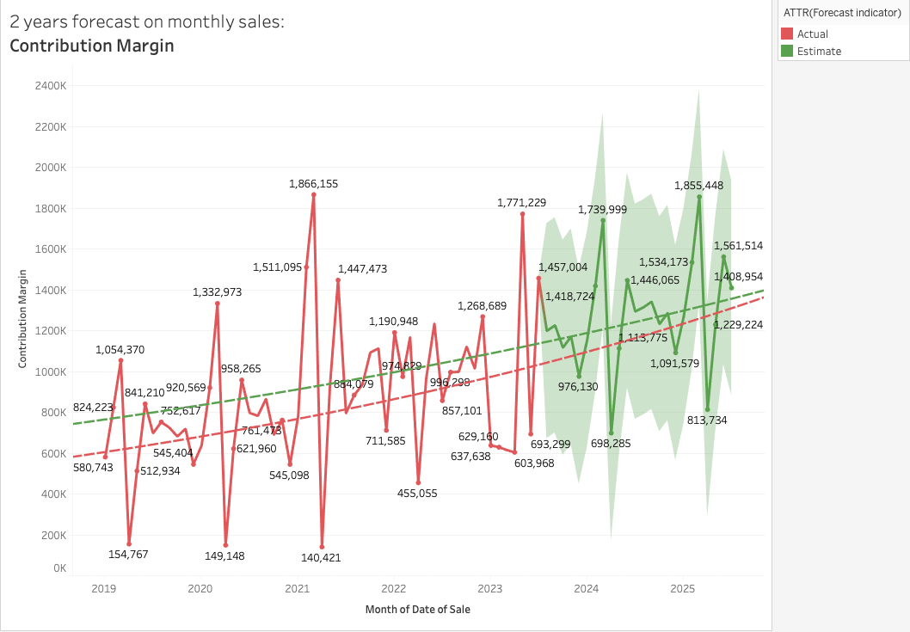
Figure 17: 2 years forecast on monthly sales

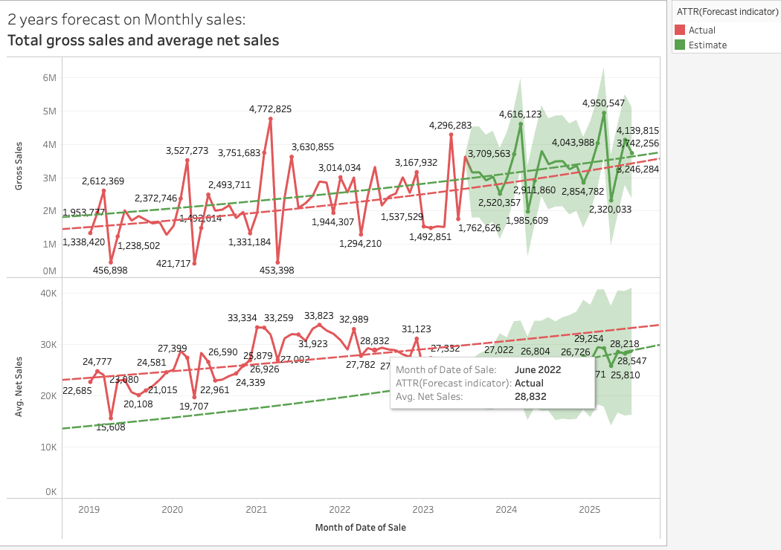
Figure 18: 2 years forecast on monthly sales

The above displays the 2 years forecasting of contribution margin that is the difference between the total sales revenue and the total variable expenses, on a monthly basis, along with trend lines.
The difference between total sales revenue and total variable expenses is represented by the projected contribution margin, a crucial financial indicator. SparkEV may use tactics like product mix optimisation to concentrate on higher-margin goods, pricing strategies to maximise profitability, and cost reduction through efficient manufacturing methods to make the most of it. A bigger contribution margin may also be attained by managing the supply chain well and keeping variable expenses under control.
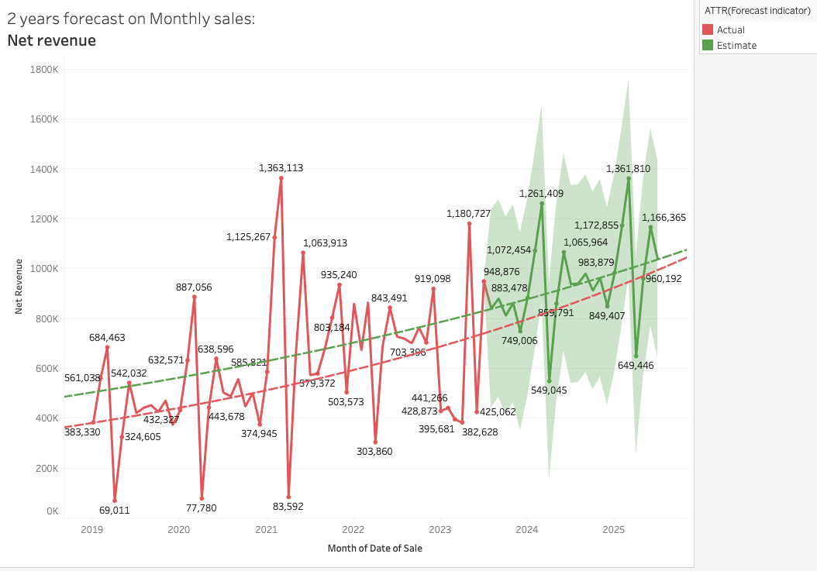
Figure 19: 2 years forecast on monthly sales

For the next two years, monthly nett revenue projections are necessary for financial planning. Seasonal changes, marketing efforts, and new product introductions are some examples of factors that might affect monthly income. Precise projections are essential for financial sustainability, resource allocation, and budgeting. Forecasts of SparkEV's monthly nett revenue are essential to the company's expansion. With the use of these projections, the business is able to effectively manage its resources, adjust to shifting market circumstances, and assess the month-to-month effects of promotions and new product introductions.
Controlling production-related costs, such as labour, raw materials, and production overheads, is a key component of total variable cost management. Opportunities for cost cutting and increased production efficiency can be found by analysing these expenses. Other expenditures, which include fixed costs like rent, salaries, and administrative expenses, are crucial to the overall financial stability of the business and must be managed well to guarantee sustainability and profitability over the long run. At SparkEV, both cost categories are essential to financial analysis and decision-making.

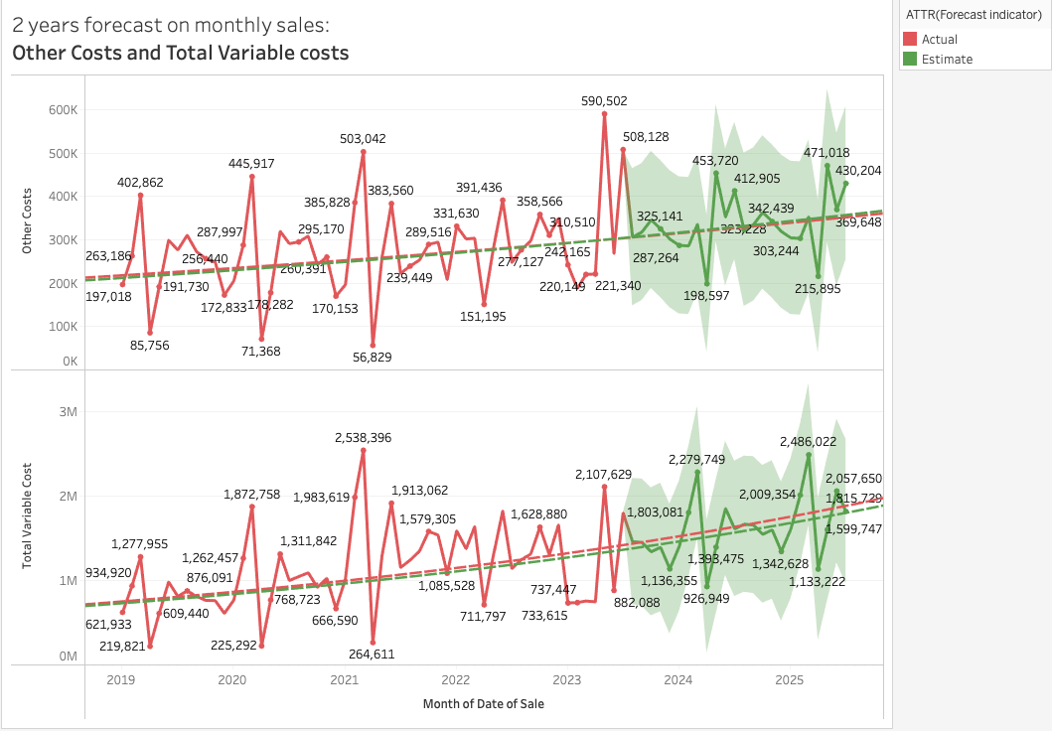
Figure 20: 2 years forecast on monthly sales

An important factor in assessing SparkEV's financial situation is the sum of its variable costs and other costs. While Other Costs include fixed overheads, administrative costs, and any other expenses unrelated to production, Total Variable Costs have a direct influence on the cost of producing each unit. For financial sustainability and profit maximization, accurate tracking and control of these cost components are crucial. Profitability and operational efficiency may be increased by analyzing patterns and making economical decisions.

How are operational costs expected to change in the upcoming years, and what variables contribute to these changes?
It is anticipated that SparkEV's operational expenses may fluctuate as a result of several variables, including global events, supply chain optimization, labor costs, raw material pricing, economies of scale, product diversification, legislation, and environmental activities. Depending on how SparkEV reacts to these factors, these modifications may take different directions.

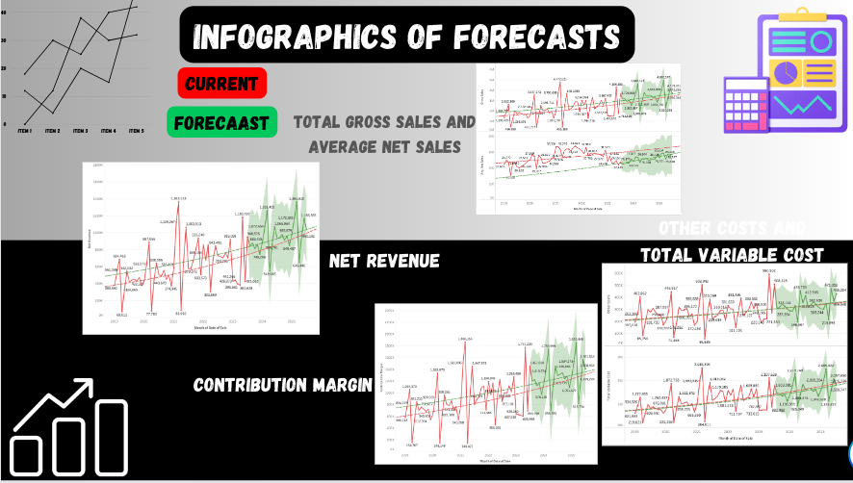
Figure 21: Infographic 4 (2 year forecast)

APPENDIX

Overall Performance Analytics
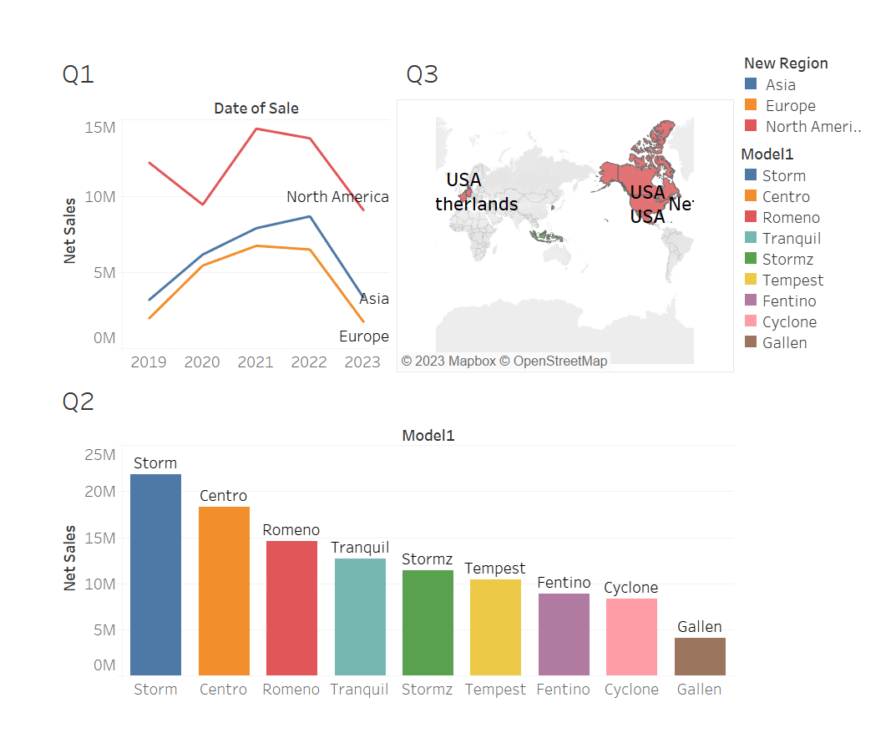
Figure 22: Dashboard 1(Overall Performance Analytics)

Financial Analytics

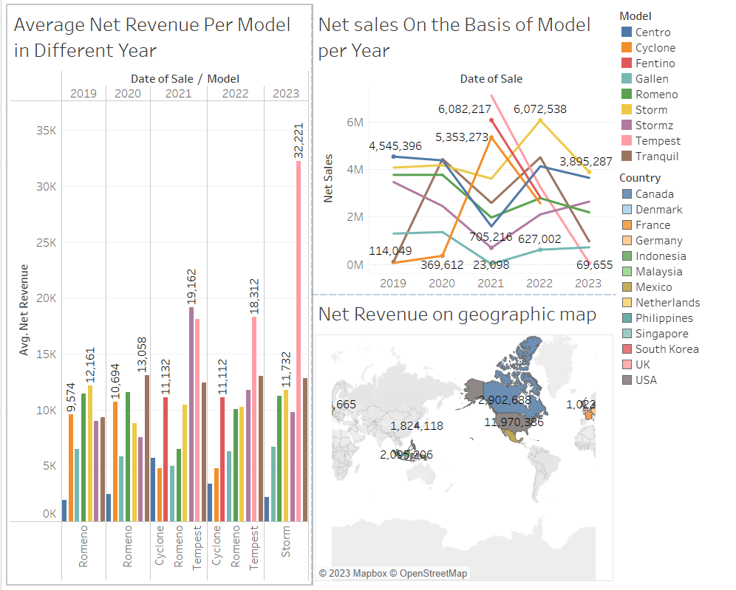
Figure 23: Dashboard 2 (Financial Analytics)

Operational Analytics
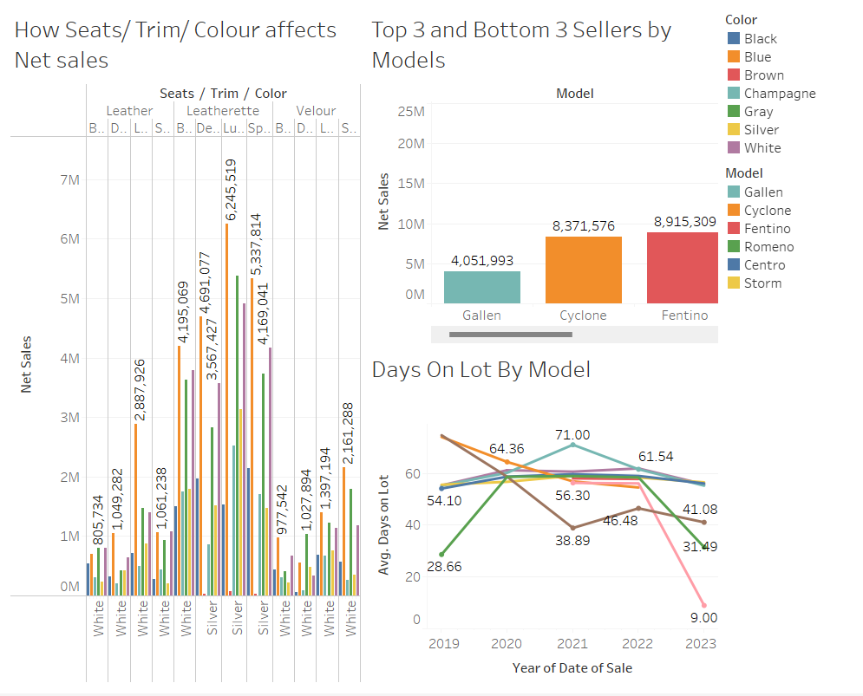
Figure 24: Dashboard 3(Operational Analytics)

2 Years Forecast Analytics
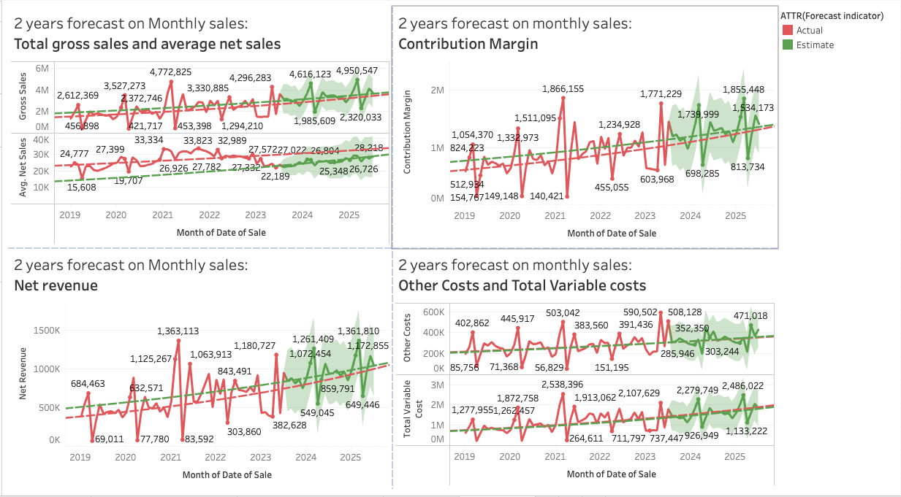
Figure 25: Dashboard 4 (2 years forecast analytics)

Conclusion

In reflecting upon the comprehensive analysis of SparkEV's market and financial performance from 2019 to 2023, several critical observations surface. Notably, while certain regions and models exhibited encouraging sales figures at different points in this timeframe, the overall trend by 2023 depicts a decline in SparkEV’s market traction across the major regions of North America, Asia, and Europe. The Storm model, while popular, couldn't counterbalance the sales descent of other models. Furthermore, the influence of manufacturing origin on sales, as well as the customer preferences for color and trim, shed light on the nuances of SparkEV's market dynamics.
The fluctuating net revenue, combined with the geographical revenue distribution, underscores a clear need for the company to reassess its market strategies. The financial projection indicates that unless there is a significant strategic intervention, SparkEV might confront more challenges ahead.
In light of this, it becomes imperative for SparkEV to introspect its current approach, product portfolio, and market strategy. The need of the hour is to engage in focused research and development, optimize resource allocation, and perhaps, consider the repositioning of certain products to align better with market demands. Embracing agility and customer-centricity will be pivotal for SparkEV to rejuvenate its market position, capitalize on emerging opportunities, and drive forward with renewed vigor in the ever-competitive electric vehicle industry.

References

- Szczepański, M. (2020). Is data the new oil? . Is Data the New Oil? Competition Issues in the Digital Economy.
- Gao, P., Kaas, H.-W., Mohr, D., & Wee, D. (2016, January 1). Automotive Revolution – perspective towards 2030. McKinsey & Company. https://www.mckinsey.com/industries/automotive-and-assembly/our-insights/disruptive-trends-that-will-transform-the-auto-industry/de-DE
- Tuovila, A. (2020, September 24). Forecasting. Investopedia. https://www.investopedia.com/terms/f/forecasting.asp
- Goh, B. W., Li, N., & Ranasinghe, T. (2023, May 23). Big Data Analytics and Management Forecasting Behavior. Ssrn.com. https://papers.ssrn.com/sol3/papers.cfm?abstract_id=4488722
- Levkovitz, R., & Ltd, O. (2014). Forecasting and big data analysis. https://forecasters.org/wp-content/uploads/gravity_forms/7-2a51b93047891f1ec3608bdbd77ca58d/2014/07/ForecastPlanner-2014-ISF-1.pdf
- ‌ Hassani, H., & Silva, E. S. (2015). Forecasting with Big Data: A Review. Analysis of Data Science, 2(1), 5–19. https://doi.org/10.1007/s40745-015-0029-9
- Keller, K.L. (2001). Building Customer-Based Brand Equity: A Blueprint for Creating Strong Brands. Marketing Management, 10(2), 15-19.
- Oliver, R.L. (1999). Whence consumer loyalty? The Journal of Marketing, 63(4), 33-44.
- Porter, M. E. (1980). Competitive Strategy: Techniques for Analyzing Industries and Competitors. The Free Press.
- Lynn, M. (1991). Scarcity effects on value: A quantitative review of the commodity theory literature. Psychology & Marketing, 8(1), 43-57.

‌

